Campus Connect

Campus Connect (https://connect.blackrivertech.org/cc3/gui_fas.html) is the means by which instructors may access and transmit student information.
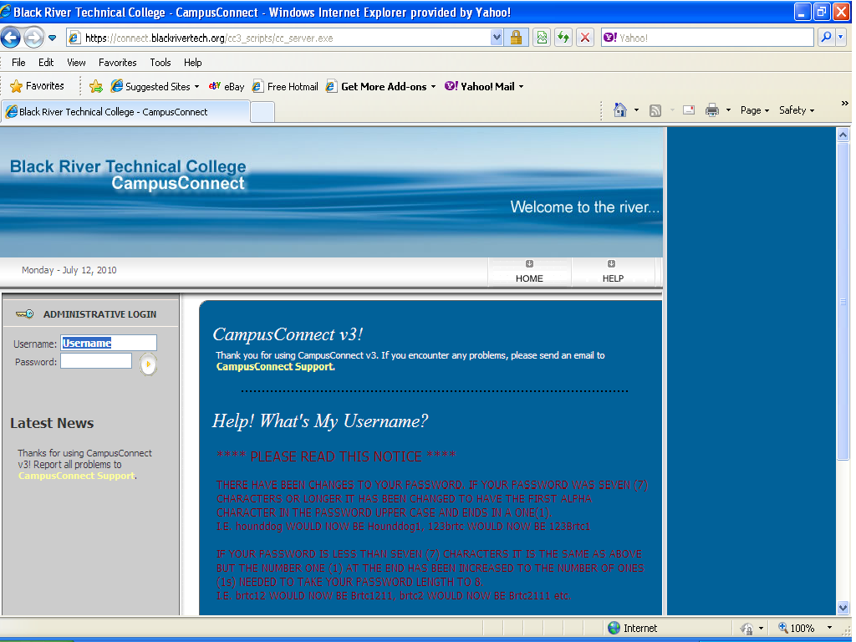
This site is used for:
- Checking course rosters
- Submitting “No-Show” rosters
- Inputting mid-term grades
- Inputting final grades

Log-in Information

Username
You will type in fac_ (underscore) followed by the first letter of your name and the first seven (7) letters of your last name. Example: Instructor Mary Johnston would type in fac_mjohnsto
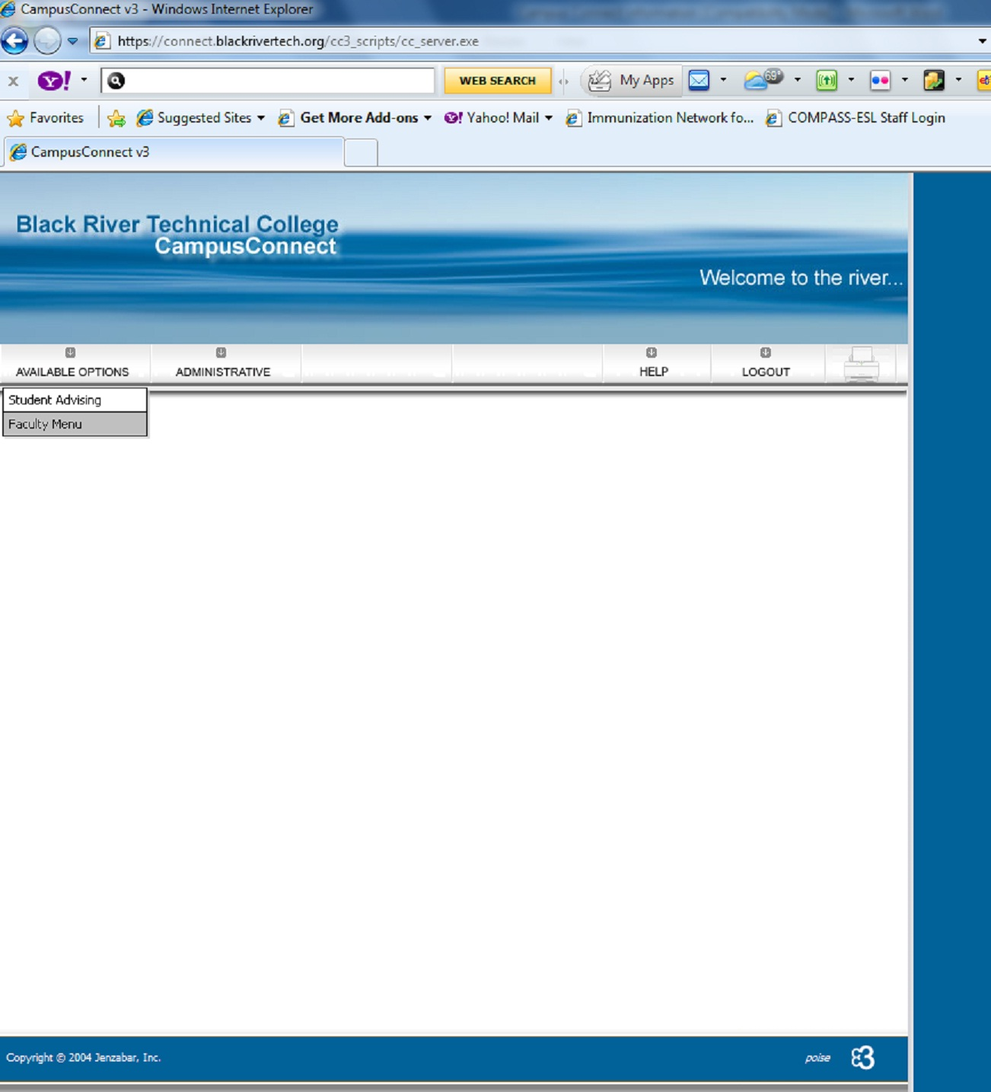

Password
When submitting your Faculty/Adjunct Information form you are asked for a password. This should be something that you are able to easily remember. This password will be used to gain access to your Campus Connect account. If this is your first time to use Campus Connect you will be notified by e-mail (or phone if you have no e-mail account) when your Campus Connect account has been established.

Course Rosters

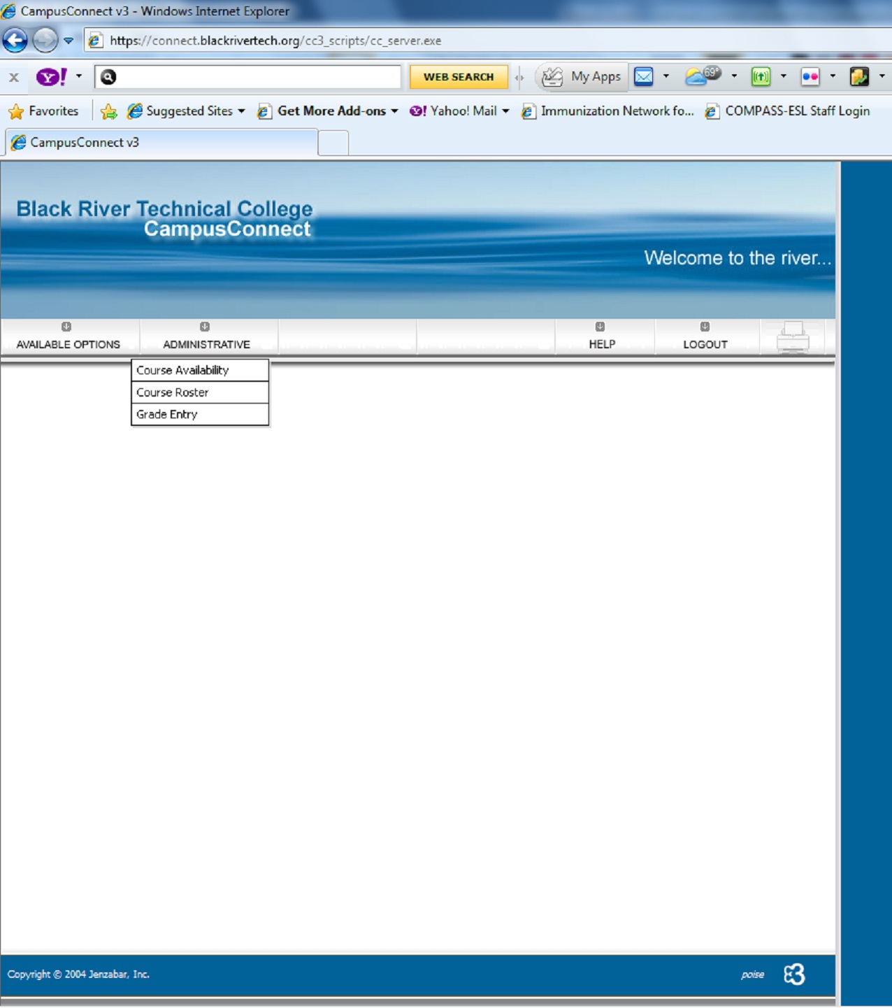
This is used to obtain a listing of the students enrolled in your class. Under “Available Options” click “Faculty Menu”. Under the “Administrative” menu, click “Course Roster”. Select the appropriate term, and click “Submit”.

Grade Entry

No-Show Submissions
No-Show submissions are transmitted as per instructions from the Registrar. Usually this is done following the second meeting of the class. You will use the Grade Entry selection for this. If a student has not attended class either of the first two meetings this student is considered a No-Show. This information is transmitted by using the drop-down arrow and entering an “N” in the Mid-Term grade column by that student’s name. When all students have been checked make sure the “No” button is selected under “Check here if this your final grade posting” and click “Submit”. In the event that all students have been present, simply go to the end of the roster (making sure the “No” is selected for “Check here if this your final grade posting”) and click “Submit”.
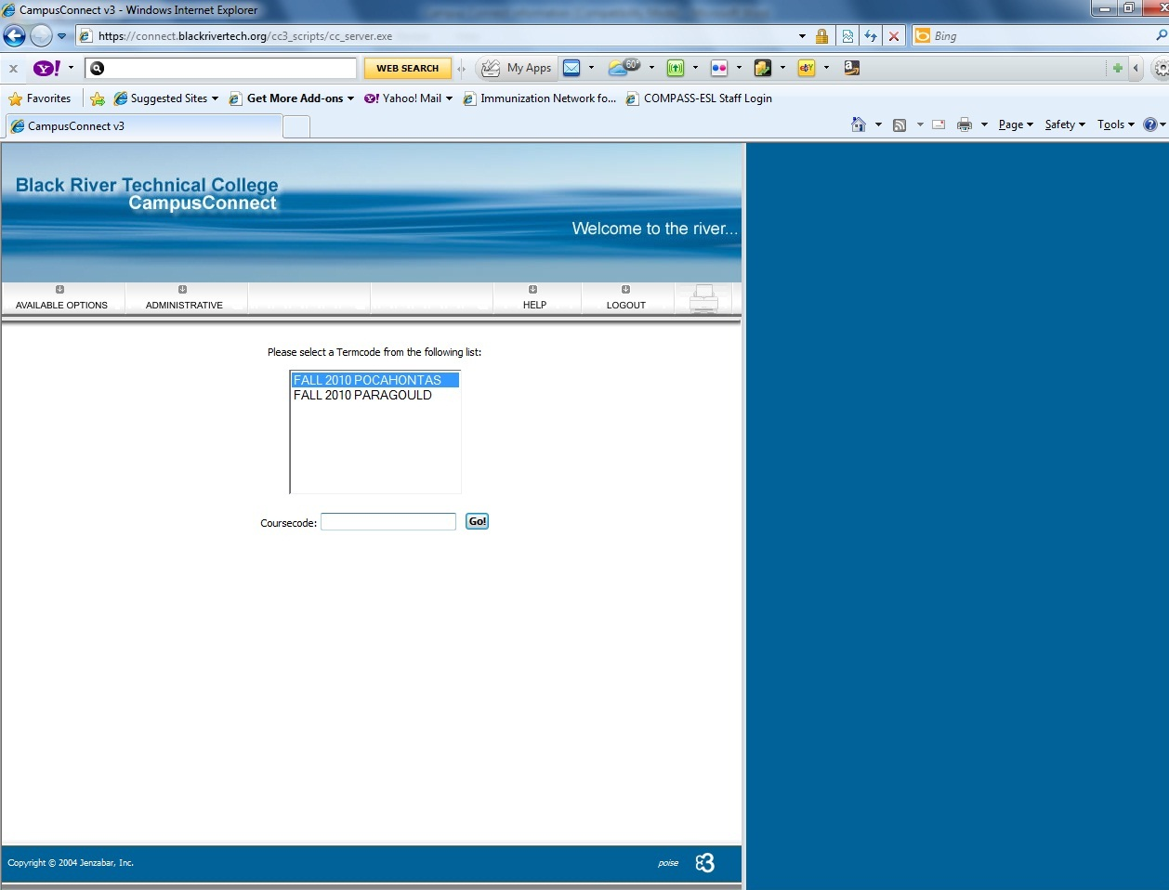
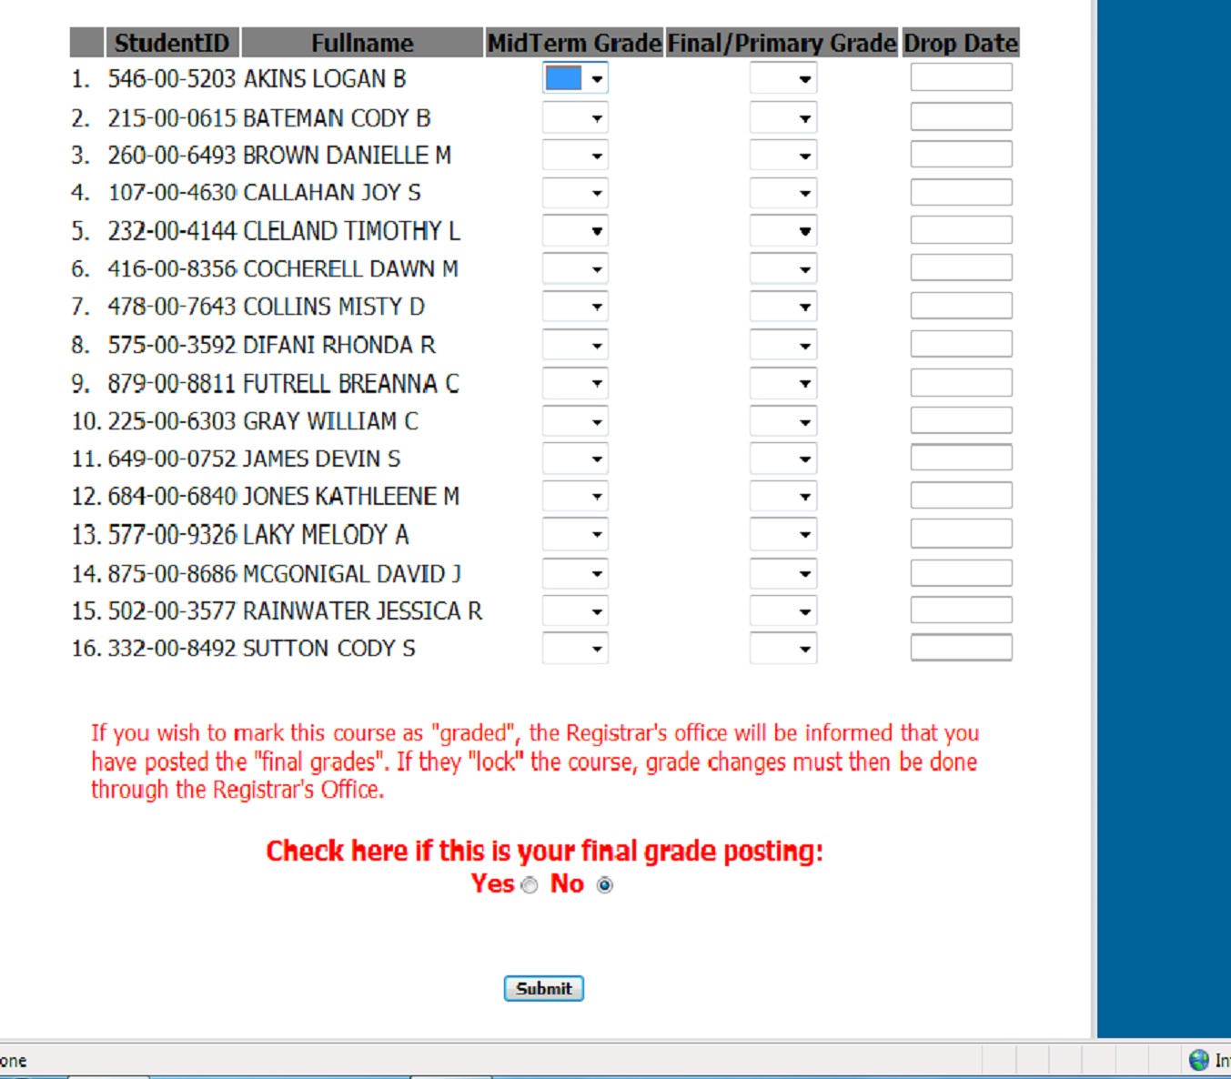
Please keep a copy of your No-Show roster. If a student tells you that your class is not on their class schedule, either they were reported as a "no-show" by you, they were dropped for nonpayment or they did not meet the prerequisites. Please ask them to come to Student Services immediately.

Also you need to check your Campus Connect roster during the second week of school. The "no-shows" have been extracted by then. Do not wait for mid-term to check your Campus Connect roster.

Mid-Term Grades
Use the drop-down arrow in the Mid Term Grade column and select the appropriate grade for each student. Be sure that you have selected “No” under “Check here if this your final grade posting” and click “Submit”.

Final Grades
Use the drop-down arrow in the Final/Primary Grade column and select the appropriate grade for each student. If a student receives a grade of “F” the “Drop Date” column will automatically populate with today’s date. Please change this date to the students last date of attendance. Select “Yes” under “Check here if this your final grade posting” and click “Submit”.

Exit

After completing the task at hand, click “Logout” to ext Campus Connect.

Problems?
If you should encounter any problems contact one of the following in Student Services (870-248-4000), Registrar, Kimberly Bigger (ext 4015), Asst. Registrar, Billie Fry (ext 4016) or Secretary to VP of Student Services, Claudette Hackworth (ext 4028).

