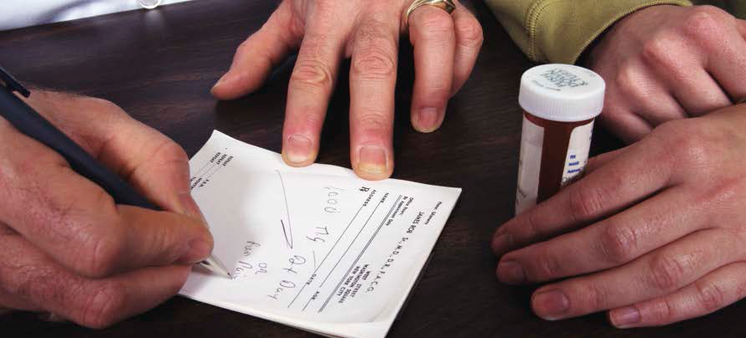

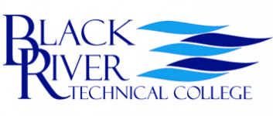

Pharmacy Technician

Education & Certification

* Students should have or be pursuing a high school diploma or GED.
* The Pharmacy Technician Certification Board’s (PTCB) is the national certification exam.
* Numerous states now require PTCB certification to work as a pharmacy technician.
* Certain national and state pharmacy technician certification exams are available.

Detailed Course Topics Covered

* The history of pharmacy and healthcare
* Pharmacy technician role and responsibilities
* Pharmacy technician certification and registration process
* Types of pharmacies including the hospital pharmacy, retail practice, long-term care practice, mail order pharmacy, home care pharmacies, and others
* Drug regulation and control
* Pharmaceutical terminology and related anatomy
* Parts of the prescription and labeling
* Pharmacy calculations and math review
* Pharmacy measures and abbreviations
* Routes and formulations
* Parenterals and compounding
* Basic biopharmaceutics
* Aseptic technique and the handling of sterile products
* Total Parenteral Nutrition (TPN)
* Basics of IV solutions and calculating 24-hour supply of IV solutions
* Factors affecting drug activity
* Information and pharmacy resources
* Inventory management and financial issues
* Brand names and generic drugs
* Drug names and drug classes

The Pharmacy Technician Profession

The need for Pharmacy Technicians continues to grow with demand expected to increase substantially through 2020. Technicians work under the supervision of a registered pharmacist in hospitals, home infusion pharmacies, community pharmacies and other healthcare settings. This high demand for pharmacy technicians is the result of a multitude of factors including the constant availability of new drugs, the national shortage of registered pharmacists, the establishment of certified pharmacy technicians, and the aging population. Approximately 400,000 technicians will be employed by the year 2018 to meet our nation’s growing healthcare demands.

The Pharmacy Technician Program

This program will prepare students to enter the pharmacy field and to pursue certification including the Pharmacy Technician Certification Board’s PTCB exam. This course covers the following key areas and topics:

* Pharmacy calculations
* Medical terminology specific to the pharmacy
* Skills to read and interpret prescriptions
* Review of the top 200 drugs
* Skills to identify drugs by generic and brand names
* Dosage calculations, I.V. flow rates, drug compounding, and dose conversions
* Dispensing of prescriptions, inventory control, and billing and reimbursement

**Course Contact Hours: 50 Hours**

**Student Tuition: $1,299 (Textbooks included)**

**Mondays and Wednesdays**

**October 16th – December 6th, 2017**

**6:00 pm – 9:30 pm**