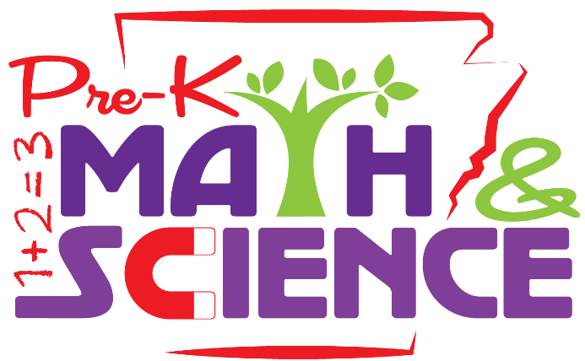

Pre-K Math and Science helps early educators:
- Understand that everyone can be a scientist
- Identify the skills and concepts that can be used to investigate the world
- Understand the importance of in-depth investigations of meaningful topics over time

Pre-K Math and Science offers the following to all participants:
- 30 hours of approved professional development credit from the Arkansas Professional Development Registry (PDR) https://pdregistry.arkansas.gov/ and the Arkansas Department of Education (ADE)
- No Charge
- Includes participant manual, course materials, and other resources
- Opportunity to collaborate with other early educators
- Certificate of Completion (upon finishing all course lessons)
- CEUs (Continuing Education Units)

Visit the Arkansas Professional Development Registry (PDR) to find available courses or call (800) 632-8754

Pre-K Math and Science taught by: Kathi Bergman
Mondays 1:00 - 4:00 p.m.
January 20 - March 23
10 Week Class
Held at BRTC in Pocahontas

For more information: email pattib@blackrivertech.edu or call 248-4180

